Marketing and Communications Officer report 2022-23

Monthly newsletter
Devised and sent out 12 x newsletters (in addition to coach sending marketing emails) one a month, open rates as follows (according to Campaign Monitor, a healthy email open rate can be anything from 20% - 40%)

Jan 84%
Dec 77%
Nov 64%
Oct 72%
Sept 65%
Aug 71%
July 77%
June 88%
May 85%
Open weekend special edition 74%
Apr 80%
Mar 80%
Feb 79%

Website stats
Jo and Matt are keeping the website updated with news blogs, events, competitions and our weekly timetable of activities. In 2022 overall we had fewer visitors to our website than 2021:
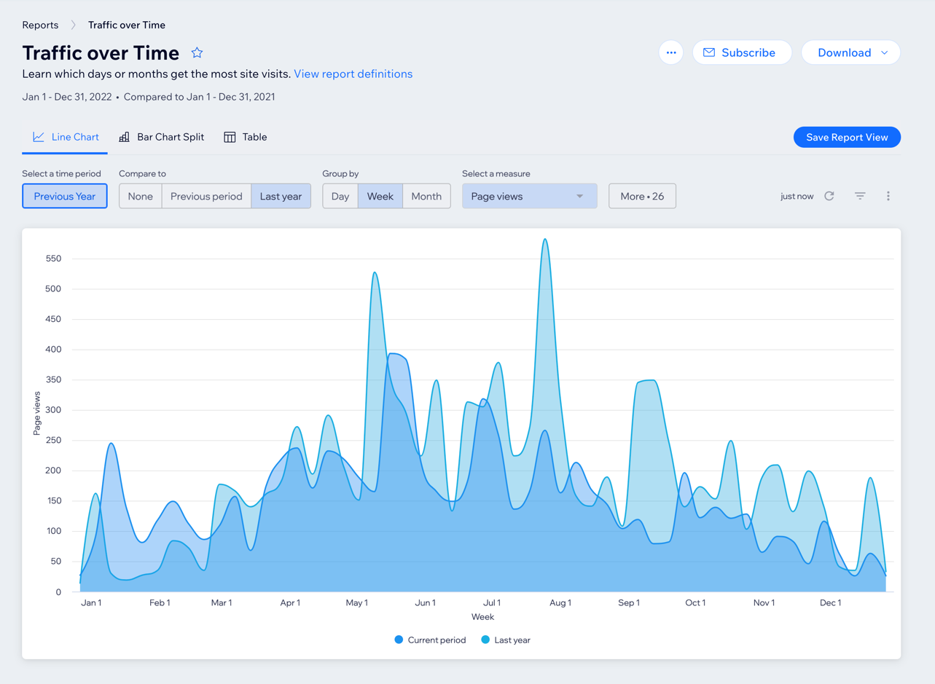

Open day, banners, posters, and social media
In addition to the large banner (March 2022) promoting junior tennis we have produced and distributed a number of A4 posters to encourage the girls’ group coaching on Tuesday evenings (March 2022) Make a Racket, plus committee members kindly distributed posters for the open day (May 2022) and we publicised it on Facebook, which had good reach stats and interest.

